Alisha Mitra  ✉: alisha.mitra1989@gmail.com  ☎: +91-9731636132 | 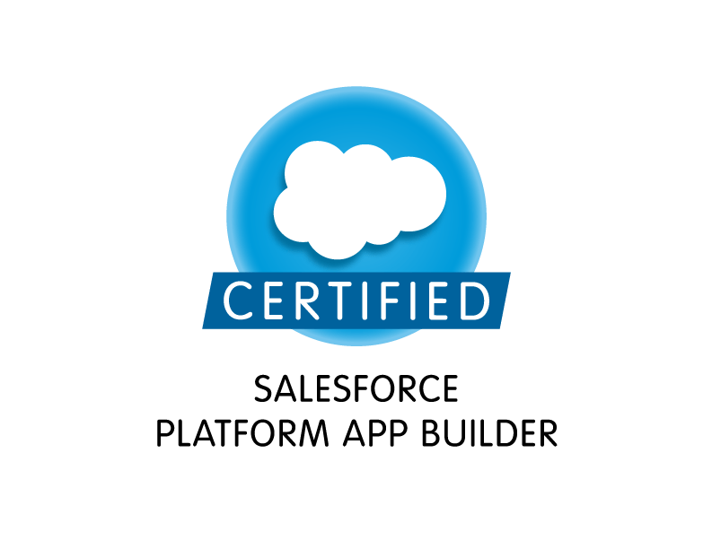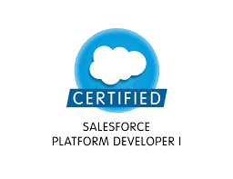

Summary
- Having 7 years of total IT experience in which 4.2 years of Salesforce experience in the role of developing applications, experience in Administration, Configuration, Implementation and Support of sales force CRM and force.com applications.
- Worked with western Union – a leading US financial services organization.
- Designed and developed Apex Classes, scheduled Apex, Batch Apex, Controller Classes, Extensions and Apex Triggers for various functional needs in the application.
- Worked on Lightning Components, process builder and visual workflows.
- Implemented security and sharing rules at object, field, and record level for different users at different levels of organization. Also created various profiles and configured the permissions based on the organizational hierarchy.
- Created the Validation Rules, Approval Process, workflows for automated lead routing, developed standard reports, Email Alerts and configured dynamic dashboards
- Self-motivated Team Player with the ability to work individually and in a group.
- Ability to learn and adapt quickly to the emerging new technologies.
- Excellent Interpersonal and Communication skills

Skill Set
Operating System | Windows Family, OS400
Programming Languages | Apex ,Javascript, SOQL,SOSL, Visual Force(Pages ,Components & Controllers)
Tools Used | Apex data loader, ANT Migration Tool, Workbench, REST

Education, Certifications and Trainings

Education: Bachelor of Engineering B.E (E&TC) from Pune University.
Certification(s):
Salesforce Administrator ADM-201
Salesforce Platform App Builder
Salesforce Sales Cloud Consultant
Salesforce Service Cloud Consultant
Salesforce Platform Developer I
nCino Certification

Professional Experience

Dates | Organization | Position
Jan -2016 to Till Date | PricewaterhouseCoopers SDC | Senior Software Developer
July-2011 to Dec -2015 | Mphasis Ltd | Delivery Software Engineer

Project Experience- Salesforce

Project Title | Treasury Management Module (May 2018 – Till Date)
Organization | PricewaterhouseCoopers SDC
Role | Salesforce Developer
Project Summary | Implementing Treasury Management solution for the financial client by leveraging salesforce Capabilities
Responsibilities Taken | - Worked on designing lightning home and record pages as per client requirements.  - Created lightning components, process builders and quick actions, Survey, Reports and Dashboards  - Worked on Triggers, Apex Classes for various functional needs in the application.

Project Title | Field Service Lightning (FSL) (Dec 2017 – April 2018)
Organization | PricewaterhouseCoopers SDC
Role | Salesforce Developer
Project Summary | Implemented end to end solution for the field service for the Internet provider client.
Responsibilities Taken | - Worked on designing lightning home and record pages as per client requirements.  - Created lightning components, process builders and quick actions, Survey, Reports and Dashboards  - Worked on Triggers, Apex Classes for various functional needs in the application.  - Configured Field service Lightning (FSL) mobile app as per the requirement.

Project Title | KeyBank Phase II(Jan-2017 – Nov 2017)
Organization | PricewaterhouseCoopers SDC
Role | Salesforce Developer
Project Summary | KeyBank implemented nCino application which is the Loan Origination System built on Force.com Platform. Worked on various aspects of configuration as well as customization as per the client’s requirements.
Responsibilities Taken | - Worked as team member and performed the roles of Salesforce.com Developer and Administrator in the organization.  - Worked on configuration tasks like validation rules, approval process, Workflow Rules etc.  - Designed and developed visual force pages, Apex Classes, Controller Classes, extensions and Apex Triggers for various functional needs in the application.

Project Title | KeyBank Phase I(Jan-2016 – Nov-2016)
Organization | PricewaterhouseCoopers SDC
Role | Salesforce Developer
Project Summary | KeyBank implemented nCino application which is the Loan Origination System built on Force.com Platform. Worked on various aspects of configuration as well as customization as per the client’s requirements. Also integrated the nCino application with other Third party systems such as Credit Bureau.
Responsibilities Taken | - Worked as a team member and performed the roles of Salesforce.com Developer and Administrator in the organization.  - Designed and developed visual force pages, Apex Classes, Controller Classes, extensions and Apex Triggers for various functional needs in the application.

Project Title | Abbott Healthcare
Organization | Mphasis Limited
Role | Salesforce Developer
Environment | Salesforce.com, CRM services(Service Cloud)
Project Summary | Abbott will use Salesforce.com to provide HR Contact Center to employees of Abbott worldwide. HR support will resolve cases, raised by employees within agrees timelines based on pre-defined SLA’s. Employee information will be visible to the agents whom the case is assigned to. Employee data will not be allowed to be edited or updated in Salesforce.com. Workday ERM will provide a committed information base system for all Human Resources. All employee data will be updated live from Workday feed. Employee records will be created for Anonymous or no record caller only by authorized person with Administrative rights. The system handles all the documentation required for the process electronically.
Responsibilities Taken | - Worked as team member and performed the roles of Salesforce.com Developer and Administrator in the organization.  - Designed and developed visual force pages, Apex Classes, Controller Classes, extensions and Apex Triggers for various functional needs in the application.  - Worked on knowledge management, applied case management functionality like assignment rules, Entitlement processes.  - Involved in writing test methods  - To work on Email2Case, Task creation on Eamil2Case  - Worked on attachments and milestones.

Project Title | CEM MpAC
Organization | Mphasis Limited
Role | Salesforce Developer
Environment | Salesforce.com, force.com tools
Project Summary | The goal of this build is to establish a predefined automated NPS Survey that will build provide Investor satisfaction results (data) to Executive Management. Our specific deployments will focus on the Investors experience with the Advisor, the Practice, the Products, the Technology, and the overall Experience. This Survey will lead up to the handover from Sales & Marketing to Operations and their “Account Opening” process.  The workflow, surveys, data, and analysis will be integrated into the Application as an extension of MpAC and will be offered as a service.
Responsibilities Taken | - Worked as team member and performed the roles of Salesforce.com Developer and Administrator in the organization.  - Designed and developed visual force pages, Apex Classes, Controller Classes, extensions and Apex Triggers for various functional needs in the application.  - Involved in writing test methods.

Project Title | Future Leaders
Organization | Mphasis Limited
Role | Salesforce Developer
Environment | Salesforce.com, force.com tools
Project Summary | The Project involved in migration of existing sales system in salesforce.com enabling the  Organization users to view their customer’s data in unified way and subsequently generate custom reports accordingly.
Responsibilities Taken | - As a SFDC developer interacting with Product Owner to understand the product requirements and suggesting best solutions and workable ideas for the product.  - Customized standard sales force objects like Contact and User.  - Administered Salesforce.com SFA setup, which involved modifying roles and profiles, creating/modifying dashboards/reports and managing users.  - Developed APEX triggers, Classes, Test methods & Visual Force pages to implement the custom functionality.  - Created use case scenarios, custom work flow and business logic.  - Involved in writing Test Methods.  - Established deployment strategy for implementing Salesforce.com changes and deployed changes by creating change sets.

Project Title | Western Union Money Transfer
Role | Synon Developer
Environment | ISeries AS400
Project Summary | Western Union a leading money transfer company in the world has different application running on AS400, of which Settlement is one of important application. WU Agent Settlement is done in SETTLEMENT application, where 4 cycles run daily to calculate various commissions and generate the different Reports for Agents, GL is generated.
Responsibilities Taken | - Monitor the Cycles and ensure on time completion as per SLA.  - Assign Adhocs to team members ensure responded to the Incidents with SLA.  - Prepare Weekly Oncall Roster, Production Support Highlights.  - Monitor repeated Oncall Incidents and Offer the solutions to reduce oncall incidents.  - Fix the bugs in the application to generate correct information, or handle error.  - Worked on the OTH (small requirements) and ensured the smooth implementation with all quality process.

Personal Information

Date of Birth : 8th March 1989
Marital Status : Single
Contact No : +91 9731636132
Location : Bangalore, India

